Triangular Pyramid (Tetrahedron)
# Source: AI Source: Provided by: [Data Path: Persons Table -> ID Column: 1, Name_En Column: Motasem Essam] -> From: [ChatGPT] on [7/25/2026]
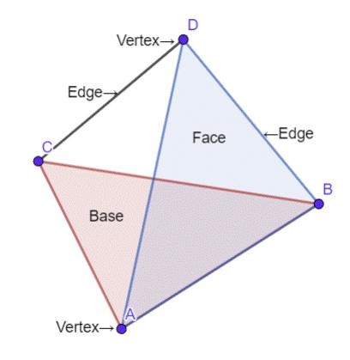
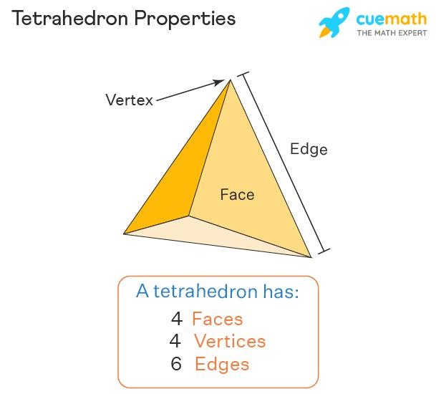
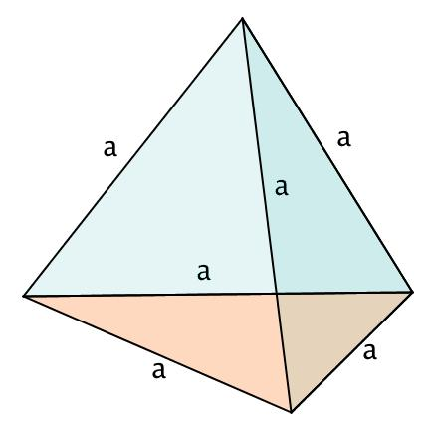

Definition
# Source: AI Source: Provided by: [Data Path: Persons Table -> ID Column: 1, Name_En Column: Motasem Essam] -> From: [ChatGPT] on [7/25/2026]
A triangular pyramid is a three-dimensional polyhedron with one triangular base and three triangular lateral faces that meet at a common vertex called the apex.
It has 4 triangular faces, 6 edges, and 4 vertices. A triangular pyramid is also called a tetrahedron. When all four faces are equilateral triangles, it is a regular tetrahedron.

Simple Definition
# Source: AI Source: Provided by: [Data Path: Persons Table -> ID Column: 1, Name_En Column: Motasem Essam] -> From: [ChatGPT] on [7/25/2026]
A triangular pyramid is a solid with:
- One triangular base.
- Three triangular side faces.
- One apex above or away from the base.
- Four vertices and six edges in total.
Unlike a triangular prism, which has two triangular bases, a triangular pyramid has only one base and one apex.

Classification Tree
# Source: AI Source: Provided by: [Data Path: Persons Table -> ID Column: 1, Name_En Column: Motasem Essam] -> From: [ChatGPT] on [7/25/2026]
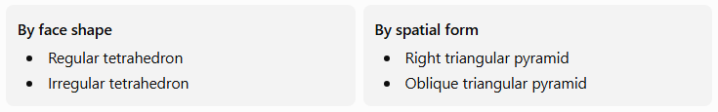
By face shape
- Regular tetrahedron
- Irregular tetrahedron
By spatial form
- Right triangular pyramid
- Oblique triangular pyramid
These classifications describe different properties. For example, a regular tetrahedron is also a right triangular pyramid, while an irregular triangular pyramid may be right or oblique.

Key Characteristics
# Source: AI Source: Provided by: [Data Path: Persons Table -> ID Column: 1, Name_En Column: Motasem Essam] -> From: [ChatGPT] on [7/25/2026]
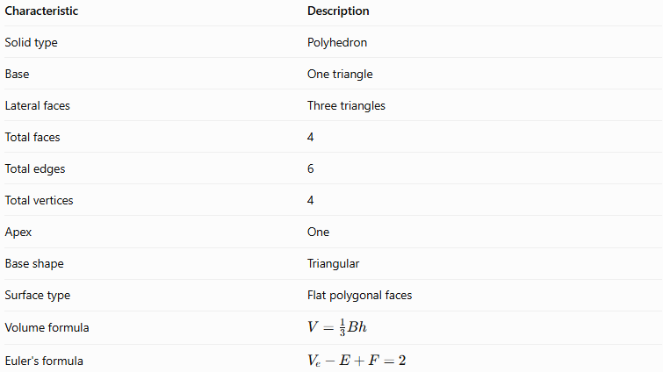
Characteristic | Description
Solid type | Polyhedron
Base | One triangle
Lateral faces | Three triangles
Total faces | 4
Total edges | 6
Total vertices | 4
Apex | One
Base shape | Triangular
Surface type | Flat polygonal faces
Volume formula | $$V=\frac{13}{B}h$$
Euler's formula | $$V_{e}-E+F=2$$
Here, $V_{e}$ denotes the number of vertices, to distinguish it from volume $V$.

Geometric Representation
# Source: AI Source: Provided by: [Data Path: Persons Table -> ID Column: 1, Name_En Column: Motasem Essam] -> From: [ChatGPT] on [7/25/2026]
A triangular pyramid can be labeled with base vertices $A$, $B$, and $C$, and apex $D$.
Its components are:
- Base face $ABC$: The triangular bottom face.
- Lateral face $ABD$: One triangular side face.
- Lateral face $BCD$: Another triangular side face.
- Lateral face $ACD$: The third triangular side face.
- Apex $D$: The vertex opposite the base.
- Base edges: $AB$, $BC$, and $CA$.
- Lateral edges: $AD$, $BD$, and $CD$.
The three lateral faces meet at the apex, and every pair of vertices is connected by an edge.

Mathematical Properties and Formulas
# Source: AI Source: Provided by: [Data Path: Persons Table -> ID Column: 1, Name_En Column: Motasem Essam] -> From: [ChatGPT] on [7/25/2026]
Let:
- $B$ = area of the triangular base
- $b$ = base of the triangle
- $t$ = perpendicular height of the triangular base
- $h$ = perpendicular height of the pyramid
- $A_{L}$ = total area of the three lateral faces
- $A_{T}$ = total surface area
- $V$ = volume

Number of faces, edges, and vertices
# Source: AI Source: Provided by: [Data Path: Persons Table -> ID Column: 1, Name_En Column: Motasem Essam] -> From: [ChatGPT] on [7/25/2026]
A triangular pyramid has:
$$F=4, E=6, V_{e}=4$$
It has one base face and three lateral faces.

Area of the triangular base
# Source: AI Source: Provided by: [Data Path: Persons Table -> ID Column: 1, Name_En Column: Motasem Essam] -> From: [ChatGPT] on [7/25/2026]
The area of the triangular base is:
$$\boxed{B=\frac{1}{2}bt}$$
Here, $b$ and $t$ refer to the base and perpendicular altitude of the triangle, not the height of the pyramid.

Volume
# Source: AI Source: Provided by: [Data Path: Persons Table -> ID Column: 1, Name_En Column: Motasem Essam] -> From: [ChatGPT] on [7/25/2026]
The volume of any pyramid is one-third of the product of its base area and perpendicular height:
$$\boxed{V=\frac{13}{B}h}$$
Since the base is triangular:
$$\boxed{V=\frac{16}{b}th}$$

Lateral surface area
# Source: AI Source: Provided by: [Data Path: Persons Table -> ID Column: 1, Name_En Column: Motasem Essam] -> From: [ChatGPT] on [7/25/2026]
The lateral surface area is the sum of the areas of the three triangular side faces:
$$\boxed{A_{L}=A_{1}+A_{2}+A_{3}}$$
For an irregular triangular pyramid, calculate each triangular face's area using its own dimensions.
For a regular triangular pyramid, where the base is an equilateral triangle and all lateral edges have equal lengths, the lateral faces are congruent isosceles triangles. If $p$ is the base perimeter and $l$ is the slant height, then:
$$\boxed{A_{L}=\frac{12}{p}l}$$
The slant height $l$ is the perpendicular altitude of a lateral face, not the vertical height $h$.

Total surface area
# Source: AI Source: Provided by: [Data Path: Persons Table -> ID Column: 1, Name_En Column: Motasem Essam] -> From: [ChatGPT] on [7/25/2026]
The total surface area includes the base and all three lateral faces:
$$\boxed{A_{T}=B+A_{L}}$$
For a regular triangular pyramid:
$$\boxed{A_{T}=B+\frac{12}{p}l}$$

Euler's formula
# Source: AI Source: Provided by: [Data Path: Persons Table -> ID Column: 1, Name_En Column: Motasem Essam] -> From: [ChatGPT] on [7/25/2026]
For a convex triangular pyramid:
$$V_{e}-E+F=2$$
Substitute its counts:
$$4-6+4=\boxed{2}$$
Therefore, the triangular pyramid satisfies Euler's formula.

Types of Triangular Pyramids

Regular Tetrahedron
# Source: AI Source: Provided by: [Data Path: Persons Table -> ID Column: 1, Name_En Column: Motasem Essam] -> From: [ChatGPT] on [7/25/2026]
All four faces are congruent equilateral triangles, and all six edges have the same length. It is the most symmetrical type of triangular pyramid.
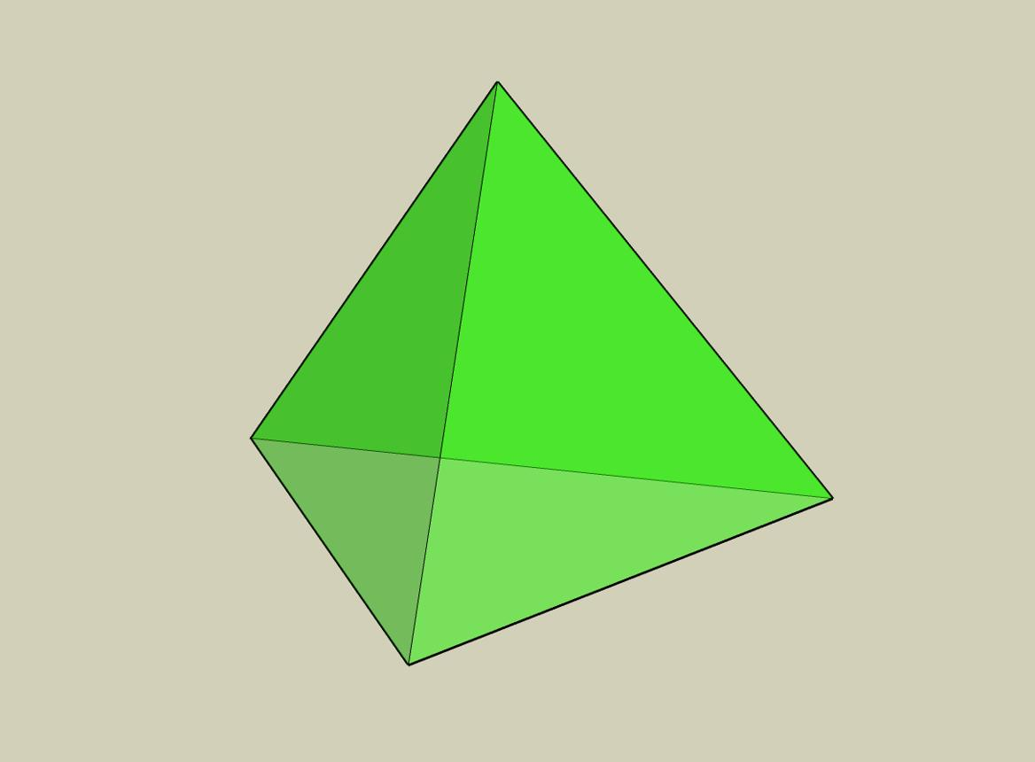

Irregular Triangular Pyramid
# Source: AI Source: Provided by: [Data Path: Persons Table -> ID Column: 1, Name_En Column: Motasem Essam] -> From: [ChatGPT] on [7/25/2026]
A triangular pyramid whose faces are not all congruent equilateral triangles. Its edges and angles may differ.
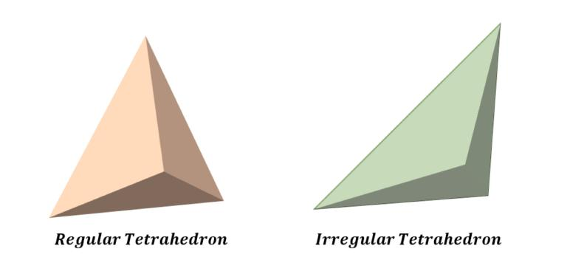

Right Triangular Pyramid
# Source: AI Source: Provided by: [Data Path: Persons Table -> ID Column: 1, Name_En Column: Motasem Essam] -> From: [ChatGPT] on [7/25/2026]
The apex lies directly above the center of the triangular base, meaning the perpendicular from the apex meets the base at its center. For a non-equilateral base, this center is commonly the triangle's centroid.
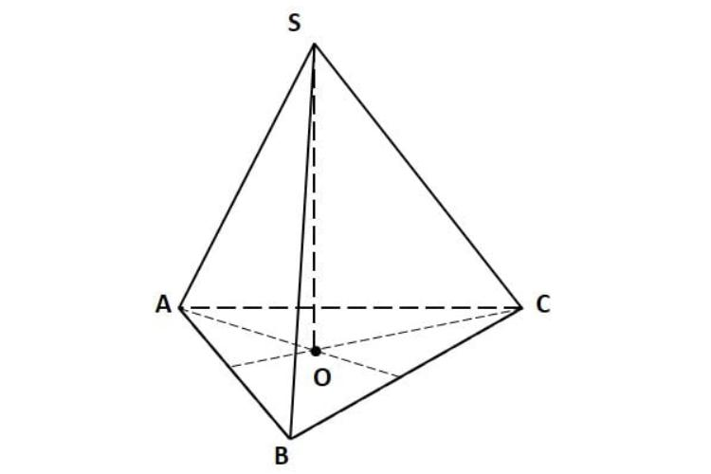

Oblique Triangular Pyramid
# Source: AI Source: Provided by: [Data Path: Persons Table -> ID Column: 1, Name_En Column: Motasem Essam] -> From: [ChatGPT] on [7/25/2026]
The apex is not directly above the center of the base, so the pyramid leans to one side.
Important distinction: A tetrahedron is any polyhedron with four triangular faces. A regular tetrahedron is the special case in which all four faces are congruent equilateral triangles.
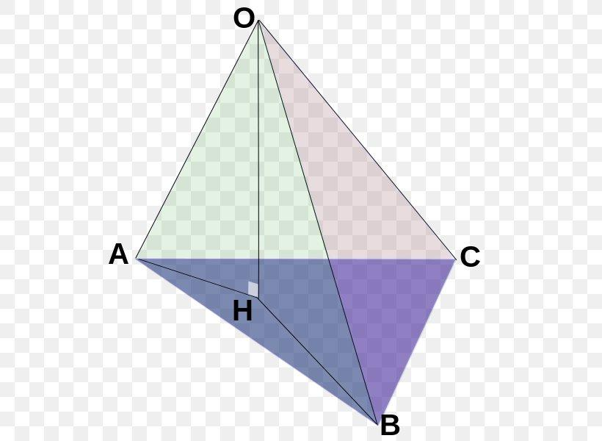

Special Formulas for a Regular Tetrahedron
# Source: AI Source: Provided by: [Data Path: Persons Table -> ID Column: 1, Name_En Column: Motasem Essam] -> From: [ChatGPT] on [7/25/2026]
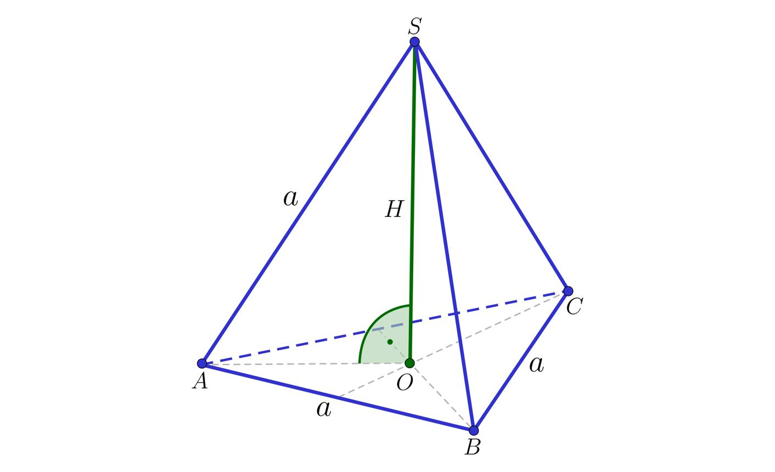
If all six edges of a regular tetrahedron have length \(a\), then the following formulas apply.
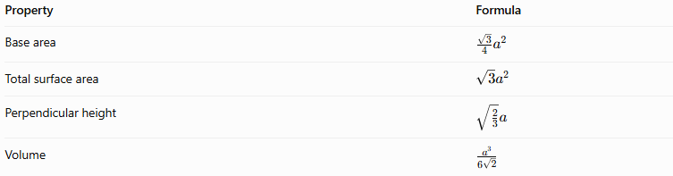
Property | Formula
Base area | $$\frac{\sqrt{3}}{4}a^{2}$$
Total surface area | $$\sqrt{3}a^{2}$$
Perpendicular height | $$\sqrt{\frac{2}{3}}a$$
Volume | $$\frac{a^{3}}{6\sqrt{2}}$$
These formulas apply only to a regular tetrahedron, not to every triangular pyramid.

Worked Examples
# Source: AI Source: Provided by: [Data Path: Persons Table -> ID Column: 1, Name_En Column: Motasem Essam] -> From: [ChatGPT] on [7/25/2026]
Example 1: Counting faces, edges, and vertices
Problem: Find the number of faces, edges, and vertices of a triangular pyramid.
Solution:
- Faces: $1+3=\boxed{4}$
- Edges: $3+3=\boxed{6}$
- Vertices: $3+1=\boxed{4}$
Answer: 4 faces, 6 edges, and 4 vertices.
Example 2: Calculating volume
Problem: A triangular pyramid has a base area of $24{\text{ cm}}^{2}$ and a perpendicular height of $9\text{ cm}$. Find its volume.
Solution:
$$V=\frac{13}{B}h$$
$$V=\frac{13}{\left(24\right)}\left(9\right)$$
$$\boxed{V=72{\text{ cm}}^{3}}$$
Answer: The volume is $72{\text{ cm}}^{3}$.
Example 3: Calculating the base area
Problem: The triangular base has a base length of $8\text{ cm}$ and a perpendicular altitude of $5\text{ cm}$. The pyramid's perpendicular height is $12\text{ cm}$. Find its volume.
Solution:
First, calculate the triangular base area:
$$B=\frac{12}{\left(8\right)}\left(5\right)=20{\text{ cm}}^{2}$$
Then calculate the volume:
$$V=\frac{13}{\left(20\right)}\left(12\right)$$
$$\boxed{V=80{\text{ cm}}^{3}}$$
Answer: The volume is $80{\text{ cm}}^{3}$.
Example 4: Calculating total surface area
Problem: A triangular pyramid has a base area of $18{\text{ cm}}^{2}$. Its three lateral faces have areas of $12{\text{ cm}}^{2}$, $15{\text{ cm}}^{2}$, and $14{\text{ cm}}^{2}$. Find its total surface area.
Solution:
$$A_{L}=12+15+14=41{\text{ cm}}^{2}$$
$$A_{T}=B+A_{L}$$
$$A_{T}=18+41$$
$$\boxed{A_{T}=59{\text{ cm}}^{2}}$$
Answer: The total surface area is $59{\text{ cm}}^{2}$.
Example 5: Checking Euler's formula
Problem: Verify Euler's formula for a triangular pyramid.
Solution:
$$V_{e}-E+F=4-6+4$$
$$\boxed{2=2}$$
Answer: Euler's formula is satisfied.

Triangular Pyramid vs. Triangular Prism
# Source: AI Source: Provided by: [Data Path: Persons Table -> ID Column: 1, Name_En Column: Motasem Essam] -> From: [ChatGPT] on [7/25/2026]
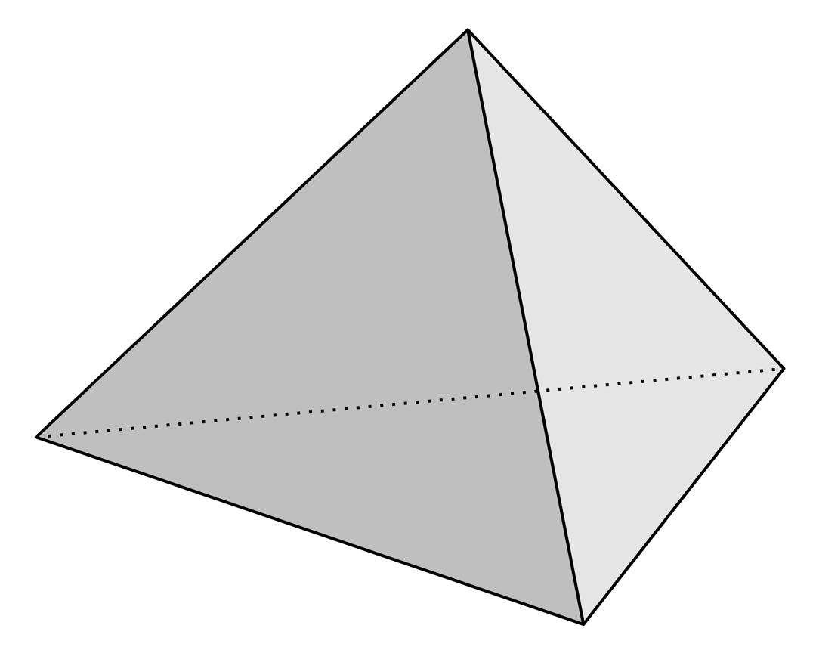
Triangular Pyramid
- One triangular base.
- One apex.
- 4 faces.
- 6 edges.
- 4 vertices.
- $V=\frac{13}{B}h$.
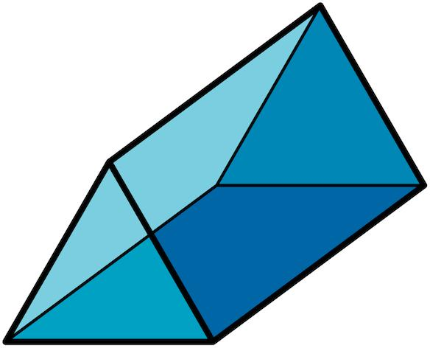
Triangular Prism
- Two triangular bases.
- No single apex.
- 5 faces.
- 9 edges.
- 6 vertices.
- $V=Bh$.
The key difference is that a triangular pyramid tapers to an apex, while a triangular prism maintains a constant cross-section between its two parallel triangular bases.

Constructing Triangular Pyramid in Solid Geometry

Instruments Used
# Source: AI Source: Provided by: [Data Path: Persons Table -> ID Column: 1, Name_En Column: Motasem Essam] -> From: [ChatGPT] on [7/25/2026]
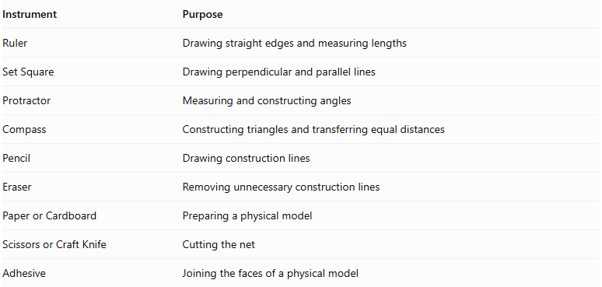
Instrument | Purpose
Ruler | Drawing straight edges and measuring lengths
Set Square | Drawing perpendicular and parallel lines
Protractor | Measuring and constructing angles
Compass | Constructing triangles and transferring equal distances
Pencil | Drawing construction lines
Eraser | Removing unnecessary construction lines
Paper or Cardboard | Preparing a physical model
Scissors or Craft Knife | Cutting the net
Adhesive | Joining the faces of a physical model

Construction Procedures

A. Base-Based Construction
# Source: AI Source: Provided by: [Data Path: Persons Table -> ID Column: 1, Name_En Column: Motasem Essam] -> From: [ChatGPT] on [7/25/2026]
- Draw a triangular base using a ruler and compass.
- Determine the position of the apex above or away from the base.
- Mark the apex.
- Connect the apex to the three vertices of the triangular base.
- Complete the three triangular lateral faces.
- Verify that all edges are properly connected.
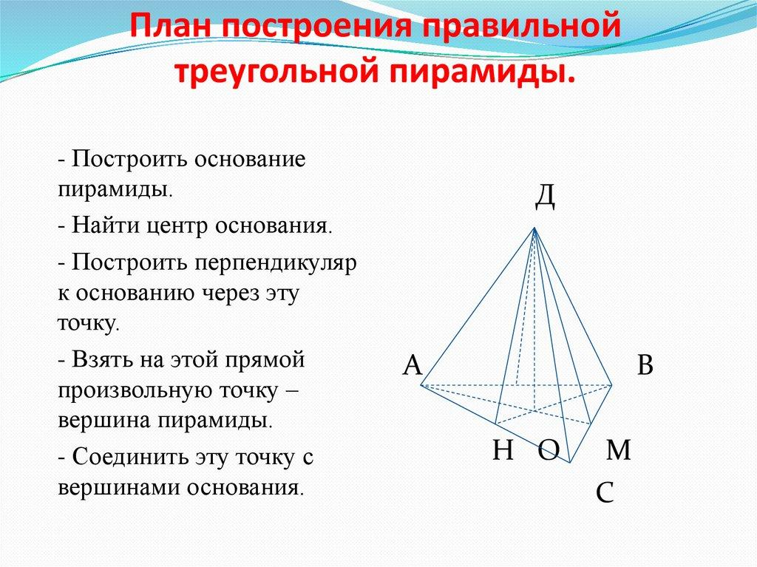

B. Apex-Based Construction
# Source: AI Source: Provided by: [Data Path: Persons Table -> ID Column: 1, Name_En Column: Motasem Essam] -> From: [ChatGPT] on [7/25/2026]
- Mark a point representing the apex.
- Construct three base vertices at the required positions.
- Connect the three base vertices to form a triangle.
- Connect the apex to each base vertex.
- Complete the four triangular faces.

C. Vertex-Connection Construction
# Source: AI Source: Provided by: [Data Path: Persons Table -> ID Column: 1, Name_En Column: Motasem Essam] -> From: [ChatGPT] on [7/25/2026]
- Identify the three vertices of the triangular base.
- Identify the apex.
- Connect the apex to each of the three base vertices.
- Verify that three lateral edges are formed.
- Confirm that the solid has four vertices in total.

D. Edge-Based Construction
# Source: AI Source: Provided by: [Data Path: Persons Table -> ID Column: 1, Name_En Column: Motasem Essam] -> From: [ChatGPT] on [7/25/2026]
- Construct the three edges of the triangular base.
- Determine the lengths of the three lateral edges.
- Construct the lateral edges from the base vertices toward the apex.
- Join their upper endpoints at the common apex.
- Complete the triangular faces.

E. Face-Based Construction
# Source: AI Source: Provided by: [Data Path: Persons Table -> ID Column: 1, Name_En Column: Motasem Essam] -> From: [ChatGPT] on [7/25/2026]
- Construct the triangular base.
- Construct the three triangular lateral faces.
- Connect each lateral face to its corresponding base edge.
- Join the lateral faces along their common lateral edges.
- Verify that the resulting solid is closed.

F. Net-Based Construction
# Source: AI Source: Provided by: [Data Path: Persons Table -> ID Column: 1, Name_En Column: Motasem Essam] -> From: [ChatGPT] on [7/25/2026]
The net of a triangular pyramid consists of:
- One triangular base.
- Three triangular lateral faces.
- Optional tabs for joining the faces.
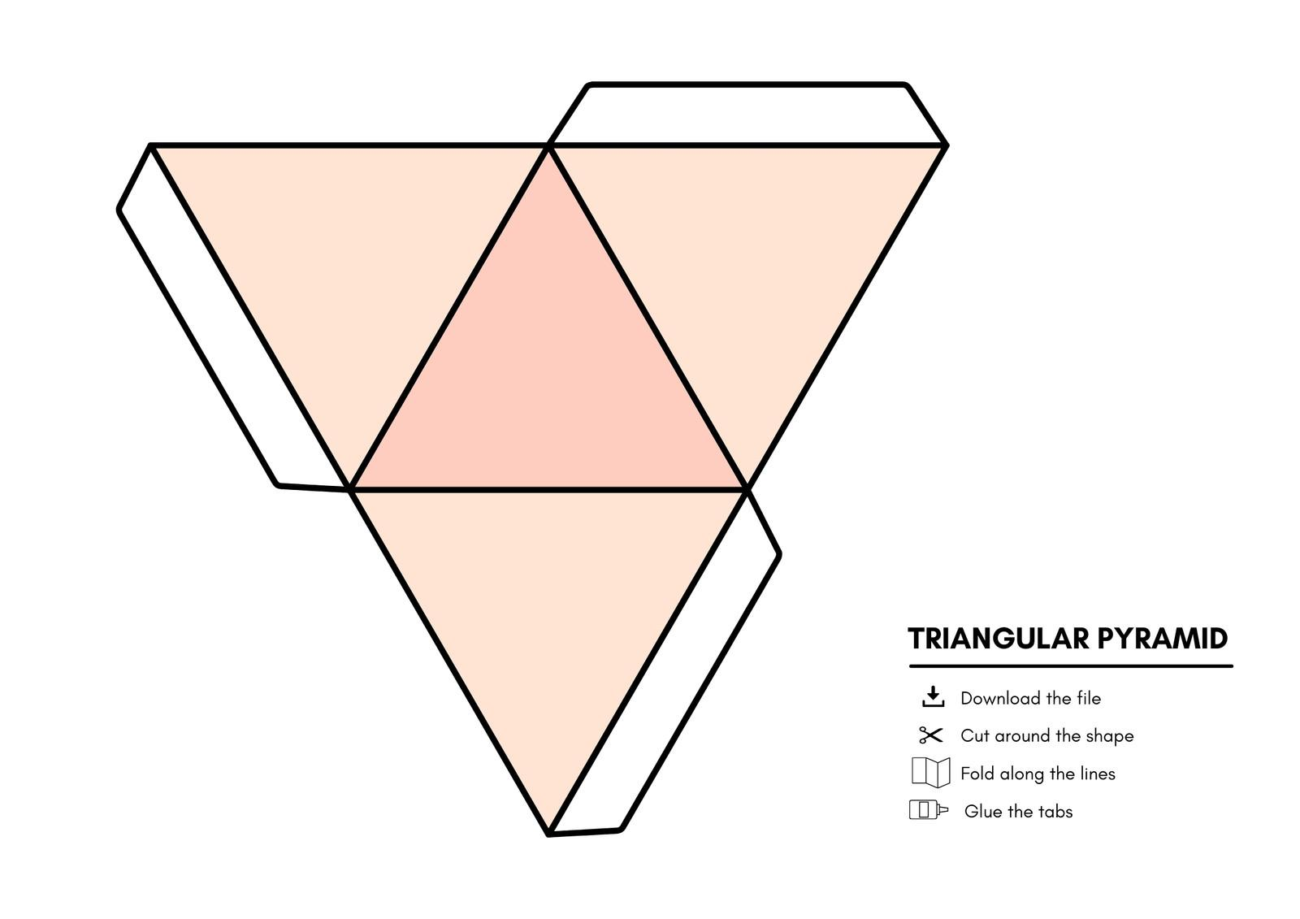

G. Physical Model Construction
# Source: AI Source: Provided by: [Data Path: Persons Table -> ID Column: 1, Name_En Column: Motasem Essam] -> From: [ChatGPT] on [7/25/2026]
- Draw the complete net on cardboard.
- Include joining tabs around selected edges.
- Cut out the net.
- Fold along the boundaries of the four triangular faces.
- Join the three lateral faces together.
- Attach the triangular base.
- Secure the edges using adhesive.

Real-World Applications
# Source: AI Source: Provided by: [Data Path: Persons Table -> ID Column: 1, Name_En Column: Motasem Essam] -> From: [ChatGPT] on [7/25/2026]
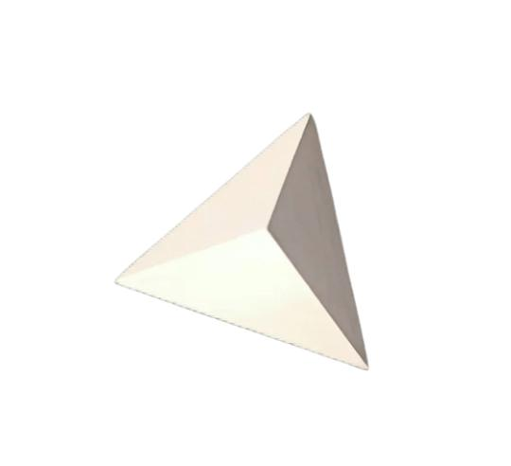
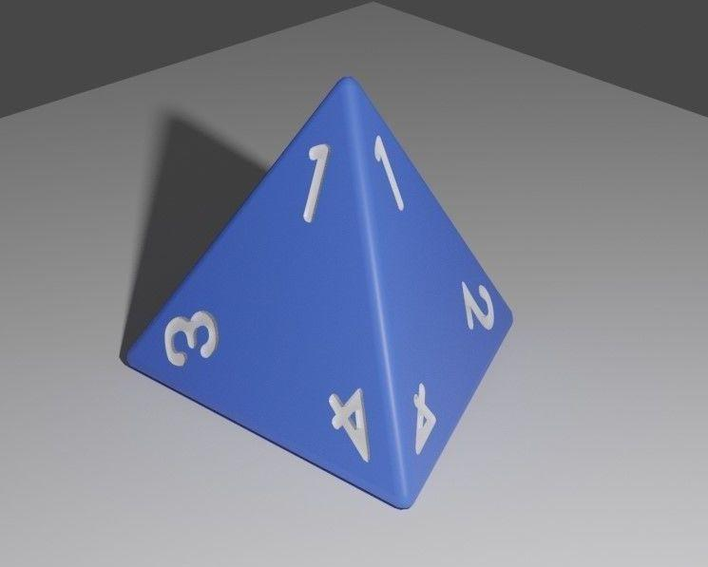
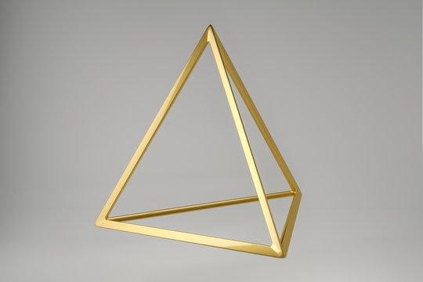
Triangular pyramids and tetrahedra are useful in:
- Architecture and structures: Tetrahedral frameworks can provide rigidity.
- Chemistry: Tetrahedral geometry describes the spatial arrangement of atoms around a central atom in many molecules.
- Computer graphics: Tetrahedra are used in three-dimensional mesh generation and volume modeling.
- Mathematics education: They illustrate polyhedral faces, edges, vertices, and Euler's formula.
- Geometric design: Tetrahedral shapes appear in sculptures, models, and modular structures.

Key Points
# Source: AI Source: Provided by: [Data Path: Persons Table -> ID Column: 1, Name_En Column: Motasem Essam] -> From: [ChatGPT] on [7/25/2026]
- A triangular pyramid has one triangular base and three triangular lateral faces.
- It is also called a tetrahedron.
- It has 4 faces, 6 edges, and 4 vertices.
- The apex is the vertex opposite the base.
- Its volume is $V=\frac{1}{3}Bh$.
- Its total surface area is the sum of its four triangular face areas.
- A regular tetrahedron has four congruent equilateral triangular faces.
- A convex triangular pyramid satisfies Euler's formula: $V_{e}-E+F=2$.

Conclusion
# Source: AI Source: Provided by: [Data Path: Persons Table -> ID Column: 1, Name_En Column: Motasem Essam] -> From: [ChatGPT] on [7/25/2026]
A triangular pyramid is one of the simplest polyhedra, consisting of four triangular faces that meet along six edges at four vertices. Its distinctive feature is a single triangular base connected to three lateral faces that meet at an apex.
Understanding triangular pyramids introduces the main properties of pyramids, including base faces, lateral faces, edges, vertices, height, slant height, surface area, and volume. The regular tetrahedron is its most symmetrical form, with all faces and edges equal.

